Use of the embedded functionality of TetGen.

The software of TetGen is embedded in Geomec and wrapped by a wrapper class CTetMesh. This class provides an easy interface of TetGen. It is important to use this class in the right way.

This is the right way of creating a tetrahedron mesh by making use of the wrapper class.

AddPoint(<geo::CPoint>)
AddSurface(<TIntList>)
AddRegion(<TDoubleList>)

CreateMesh()

It’s obvious that all methods should be called more times for more points, faces and/or regions.

The integer list that is given along the call of AddSurface should be in an ordered way. Tetgen is not zero-based but start with 1.

<#Faces><#Points><Point1>…<PointN>…

The double list for a region is ordered like this.

<x><y><z><regionnumber><meshfactor>

Example :

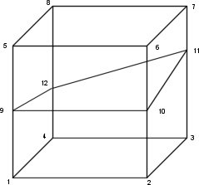

AddPoint(0,0,0); // point 1
AddPoint(..) // Point 2 to 12
AddSurface(<1,4,1,2,3,4>);
AddSurface(<1,4,1,2,10,9>);
…. // Add all the surfaces
AddRegion(<1,1,1,1,1.5>); // Region 1
AddRegion(<1,1,9,2,0.7>); // Region 2
CreateMesh();

